. Write a C program to simulate page replacement algorithms.
a) FIFO
b) LRU
c) Optimal

#include <stdio.h>

void run_algo(int pages[], int n, int f, char *name, int type)
{
int frames[20], time[20] = {0};
int faults = 0, fifo_idx = 0;

for (int i = 0; i < f; i++)
frames[i] = -1;

printf("\n- - - %s Result - - -\n", name);

for (int i = 0; i < n; i++)
{
int hit = -1, empty = -1;

for (int j = 0; j < f; j++)
{
if (frames[j] == pages[i])
hit = j;

if (frames[j] == -1 && empty == -1)
empty = j;
}

if (hit != -1)
{
if (type == 3)
time[hit] = i;
}
else
{
int rep = empty;

if (rep == -1)
{
if (type == 1)
{
rep = fifo_idx;
fifo_idx = (fifo_idx + 1) % f;
}
else if (type == 2)
{
int far = -1;

for (int j = 0; j < f; j++)
{
int k;

for (k = i + 1; k < n; k++)
{
if (frames[j] == pages[k])
break;
}

if (k > far)
{
far = k;
rep = j;
}
}
}
else
{
int min = time[0];
rep = 0;

for (int j = 1; j < f; j++)
{
if (time[j] < min)
{
min = time[j];
rep = j;
}
}
}
}

frames[rep] = pages[i];
time[rep] = i;
faults++;
}

printf("Ref %2d -> [", pages[i]);

for (int j = 0; j < f; j++)
{
if (frames[j] == -1)
printf(" -");
else
printf(" %d", frames[j]);
}

printf(" ] %s\n", hit != -1 ? "Hit" : " ");
}

printf("Total Page Faults: %d\n", faults);
}

int main()
{
int f, n, pages[50];

printf("Enter number of frames: ");
scanf("%d", &f);

printf("Enter no pages in reference string: ");
scanf("%d", &n);

printf("Enter the reference string: ");

for (int i = 0; i < n; i++)
scanf("%d", &pages[i]);

run_algo(pages, n, f, "FIFO", 1);
run_algo(pages, n, f, "Optimal", 2);
run_algo(pages, n, f, "LRU", 3);

return 0;
}
Output:
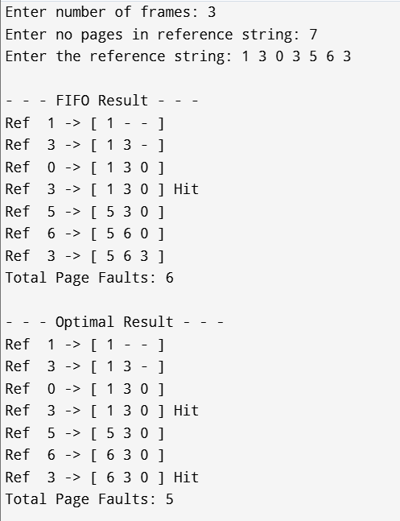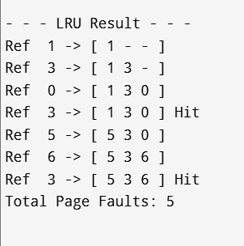

Observation:

